Registration Form
Market Garden – 2017

This registration form will register one individual person for the 2017 Market Garden event organized
by RCPT The Netherlands. This is the only valid form with which an individual person (jumper/non-jumper) can register for the event.
Jumping participants must possess a valid third party insurance covering parachute jumping and a current “fit to jump” medical attest.

PERSONAL DATA
Name : Click here to enter text.
Surname : Click here to enter text.
Nationality : Click here to enter text.
E-mail Address : Click here to enter text.
Cell phone number : Click here to enter text.
Date of last jump : Click here to enter text.
Number of jumps(last 12 months) : Click here to enter text.

The minimum required total round canopy jumps to jump from a C-47 is 5. The chief jumpmaster has final decision.

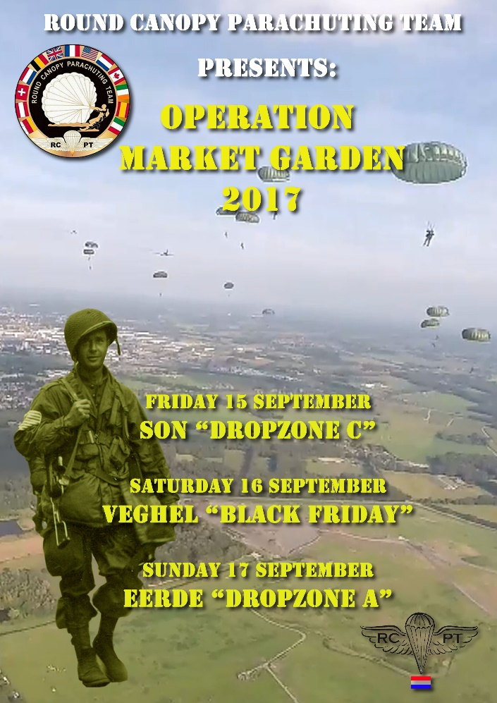

JUMPS
Preferred uniform for all the jumps is US M43 plus jump boots & airborne helmet. (Fixed D-bale helmets are NOT allowed). US M42, BRITISH WWII Para Uniform or your current national para uniform are allowed.
For Market Garden 2017 we offer the following Jumps:
1. Friday, September 15
Son DZ “Operation Paulushoef” DZ C Memorial Jump Jump price € 200.00

2. Saturday, September 16
Veghel DZ “Operation Black Friday” Memorial Jump Jump price € 200.00
3. Sunday, September 17
Eerde DZ “Operation Joe Mero” DZ A Memorial Jump Jump price € 200.00

EXTRAS
During our Market Garden event we always organise a team dinner and a team BBQ.
This year there will be no difference!
Friday 15 Sept. Dinner Wok in Erp (Asian) € 23.75 (drinks - wine/beer/soda - included)
Saturday 16 Sept. Team BBQ at windmill in Eerde € 17.50 (drinks not included)
Sunday 17 Sept. Dinner Vlas & Graan (3-course buffet) € 18.00 (drinks not included)
Extra program information:
Jump Son 15 September:
After the jump in Son we would like to visit the family Van Overvelt near the DZ with the team. They are the original inhabitants of the house (Paulushoef) where 2nd battalion 506 assembled before heading towards Son. Wan van Overvelt was a small boy during the war and witnessed the jumps. He has a small museum with artefacts of that dropzone, parachute and glider related.
Jump Eerde 17 September:
It’s a DZ that has not been jumped on since 1944. The whole team can afterwards participate in the official commemoration in Eerde.

EQUIPMENT
If own equipment is used - paperwork will be inspected before the jumps.
All equipment has to be rigger inspected. (1 year for main, 6 months for reserve)
Notice
This year unfortunately we do not have rental rigs.

Main Parachute
Only steerable round canopies are allowed. Types such as MC1-1C/D, SET10, SF-10.
Reserve Parachute
Reserves - only MIRPS (centre- or side pull) or modified T10R with MA1 kicker plate are allowed.

Opening System
We only allow the direct-bag opening system. Pilot-chute assist systems are not allowed.

ACCOMODATION

This year we have a unique historical location at Veghel, the “Noordkade”. This is an old industrial complex which is turned into a local center of Culture and food. Here you will find shops, restaurants, cinema and bars. In September 1944 this was a part of the Headquarters of the 101st Airborne Division where General McAuliffe lead the division in Veghel when the Germans cut the Hell’s Highway on two occasions. In Veghel the liberation fair will be held in the weekend that we are participating in the commemorations. Also a lot of reenactors will be staying at this location too. Lodging will be simple (depending on the number of people staying here, possibly an open space within the complex will be shared with reenactors), toilets and showers will be provided (units). In the small fee of € 30.00 for 4 nights fieldbeds and sleeping bags are included. We are negotiating that this will be including breakfast for those who decide to stay here. The center of Veghel is within walking distance.

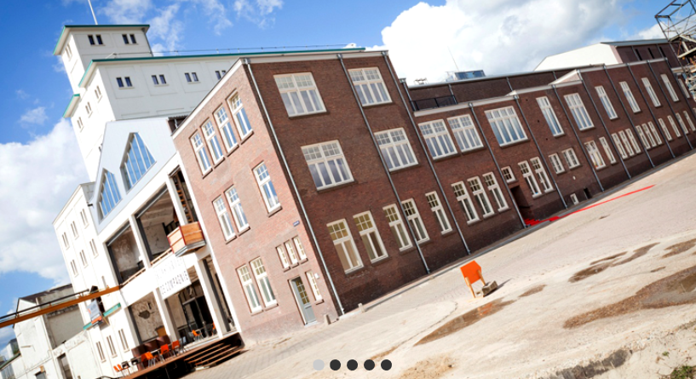

Registration part (please tick the appropriate boxes)
Jumps Please register me for:
☐ Jump 1 – Son DZ “Operation Paulushoef” DZ C Memorial Jump
☐ Jump 2 – Veghel DZ “Operation Black Friday” Memorial Jump
☐ Jump 3 – Eerde DZ “Operation Joe Mero” DZ A Memorial Jump

Extras Please register me for:
☐ Register for Dinner Wok in Erp (Asian)
☐ Register for Team BBQ at windmill in Eerde
☐ Register for Dinner Vlas & Graan (3-course buffet)

Accommodation Please register me for:
☐ Lodging at historical Noordkade (including cot and sleeping bag)

IMPORTANT NOTICE!
After filling out this form and sign-up for your jumps, send it to the e-mail address
dominique-jame@orange.fr .

Your registration will be valid only if the adequate total payment is received

Payment details:

- By PayPal to bank.rcpt@orange.fr , (in case you pay by Paypal, make sure you take the fees for your
account.)
- Bank wire to Round Canopy Parachuting Team
IBAN : FR76 3000 3018 9100 0372 6303 117
BIC/SWIFT : SOGEFRPP

Or limited to French residents only
– by bank check to:
RCPT, Saussetour 3, 50310 Fresville, France

